

Scheduling Cognos
Reports

COG 111
Cognos Version 12.1.1

July 2026

Business Intelligence Competency Center

Copyright © 2026 by Purdue University. All rights reserved. Some topics of this manual reference IBM Cognos proprietary materials.
Permission to print or copy this material is granted to Purdue University faculty and staff for Purdue business purposes. Any other reproduction or use requires written permission of Purdue IT Business Intelligence Competency Center, Purdue University.
Table of Contents
Introduction 4
Scheduled Report Location 4
Create a New Folder and Report View 5
Move a Report View to a Folder 8
Schedule Cognos Reports to Run Automatically 11
Edit Prompts in a Schedule 17
Disable or Delete a Schedule 18
Set Report Outputs and Run Histories 19
View Run History 20
Using Jobs to Schedule Multiple Entries 23
Subscriptions 27
Setting up a Subscription 27
My Schedules and Subscriptions 29
Departmental Scheduled Reports 32
Do I Have Write Access to My Departmental Folder? 32
Renewing Cognos Credentials after Network Password Change 33
Cognos Scheduler Policies and Procedures 34
Cognos Scheduler Best Practices Guide 35
Troubleshooting 36
Feedback on this Document 36

Introduction
Cognos offers a report scheduling feature to run reports at recurring dates and times based on your business needs. The output can be saved to the Cognos servers and/or emailed to Purdue email accounts. Users have the option of disabling the schedule and re-enabling it without removing the report from the scheduled objects.

Along with this training, please be aware of the Cognos Scheduler Policies and Procedures and the Cognos Scheduler Best Practices Guide. Content for the documents is covered in this training and included at the end of this document. Quick Reference Cards (QRC’s) for both documents can be found on the Resources page in Cognos under the Cognos General Reporting Links section.

Scheduler Use Warnings for All Users

- Users must have a Cognos license to create Schedules & Subscriptions on the scheduler.
- Users must renew credentials in Cognos after changing their university password.
- User security may affect where scheduling can be used/saved.
- Users must maintain prompt values for schedule output to render the proper outcomes.
- Reports will fail if Cognos or its data sources are unavailable at the time a report is scheduled to run.

Scheduled Report Location

There are different ways to schedule report output based on the user’s business needs and the user’s write access to folders. All users have write access to My content. Scheduling reports in My content is more for personal report use and can only be changed or maintained by the user. (Scheduling reports in My content is covered starting on page 11).

Users may be given write access to their departmental folders. This allows scheduled reports to be saved and used by others in the department. Scheduled reports can then be maintained by anyone in the department with write access. This is very helpful with staff turnover, as scheduled reports can be reassigned to a new or different user.

This training manual assumes users have completed COG 101 Cognos Analytics Navigation

Create a New Folder and Report View

NOTE: Users will need to create a Report View of the report they wish to schedule. DO NOT SCHEDULE THE ORIGINAL REPORT!

- Log in to https://qa.reporting.purdue.edu/.

    - NOTE: We will be working in the above test environment for this training.
    - Outside of this training, the general-use URL (PROD) for Cognos is https://reporting.purdue.edu/

- Click on the My content tab.
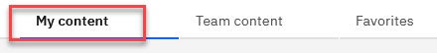
- Create a new folder by clicking on the New Folder icon in the My content panel.

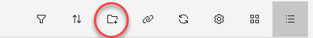
Name it My Scheduled Reports. Click Enter.
- Add a description in the Description block if you prefer. Click on the ellipsis to the right of the folder name and choose Properties.
- The Properties pane for the folder will open, and on the General tab under Description, enter the description you want.
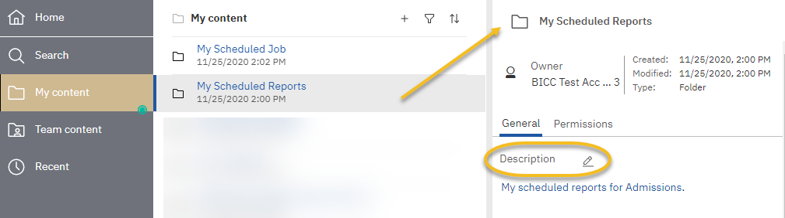

- Click anywhere in the Content Pane to close the Properties pane.

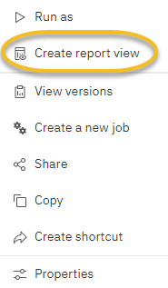
- Navigate to the Customer Lifetime Value Analysis report by clicking on Team content > Samples > Reports > Standard Reports. Click the ellipsis to the right of the Customer lifetime value analysis report to make a reporting view. Select Create report view.

- Select My content and then Save.
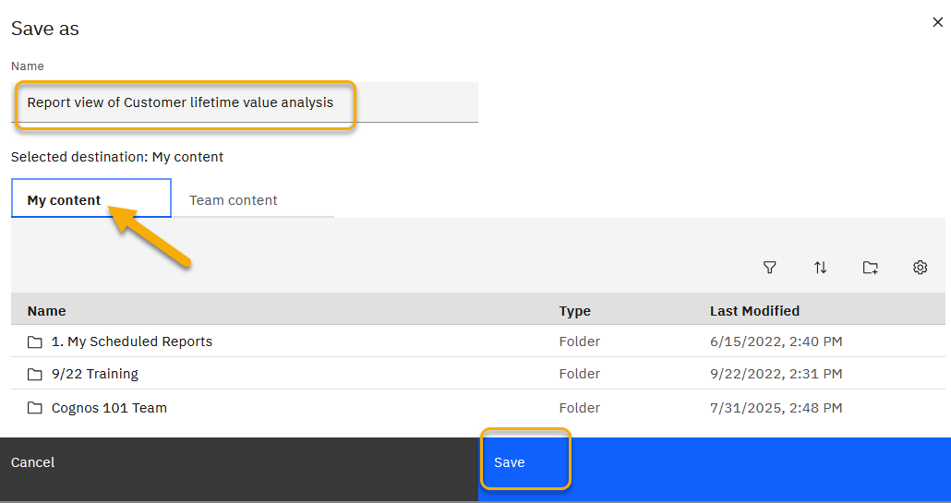

- Navigate to My content to view the new report view.

NOTE: You must click on the title of a folder to open it.


NOTE: Users will only be able to save the report in their My content folder or their departmental folder in Team content.

Notice that the report name has been changed to Report view of Customer Lifetime Value Analysis. Cognos defaults to the report's original name and adds "Report view" at the beginning. The report will be alphabetized within the list. Notice the report icon has changed.

Move a Report View to a Folder
- Navigate to the report view in the My content folder and click on the ellipsis to the right of the report. Choose Copy or move.

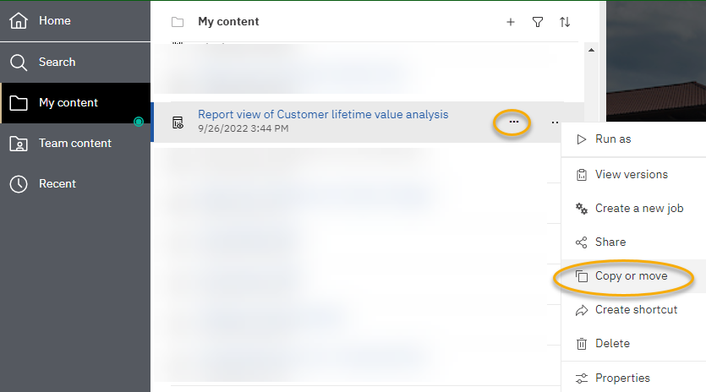

- On the Copy or move pane, if not already positioned there, navigate to the My content folder by clicking on the My content title within the breadcrumb menu. This will position you at the root level of My content.

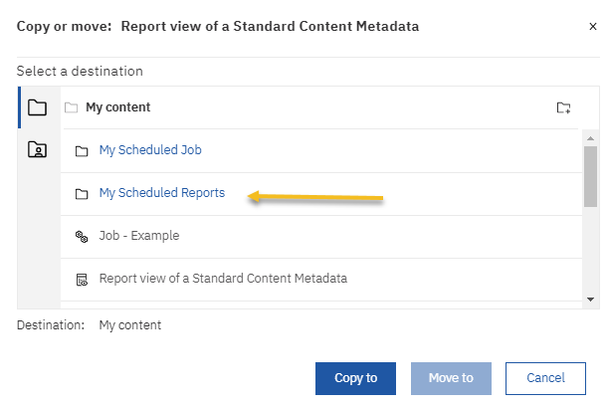
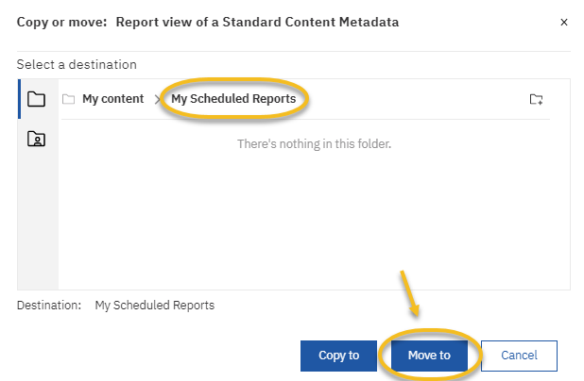
- Click on the name of the folder you created, My Scheduled Reports, to choose the destination. Click Move to.

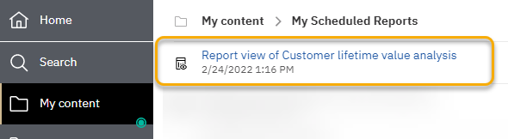
- Open the My Scheduled Reports folder to see the report view by clicking on the folder name.

- The report will be alphabetized within the list.

- Add a Description to the report view if desired. To add a description, click the ellipsis to the right of the report name. Choose Properties from the pop-up menu. 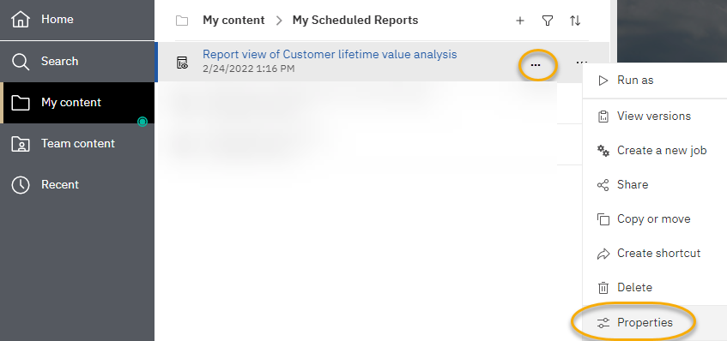

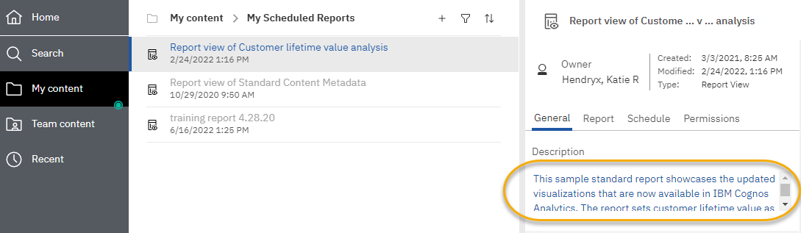
- To add a description.

- After entering the description, click Save, then select Close to close the Properties pane. Then, navigate to the My Content folder by clicking on the breadcrumb menu.
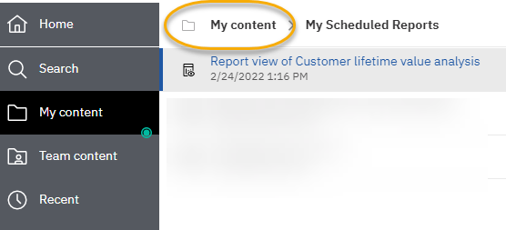

Schedule Cognos Reports to Run Automatically
- Open My Scheduled Reports folder.
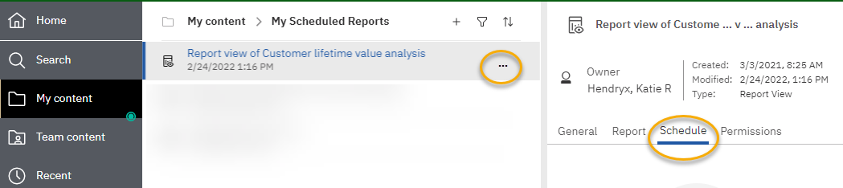
- Click on the ellipsis to the right of the report title and choose Properties, click on the Schedule tab, and then click the Create schedule button.

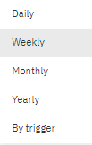
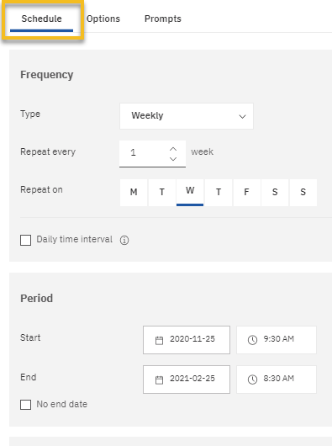
- The Schedule settings window will open over the Properties pane.
Use to set day(s) of the week, specific dates, or specific days and months.

Use to set schedule frequency
‘By trigger’ NOT available
Use to set Start and End Dates

Schedule Tab settings:
- Choose the Frequency for the report to run - Options change with each frequency option.
Daily | Days and Time
Weekly | Week, Day of the Week, and Time
Monthly | Day by Week, Date, Month and Time
Yearly | Day by Week, Date, Month and Time

- Choose a Start Date and time - The selected time determines the time and date the report will start processing in Cognos. If reports are long running, consider setting the start time for early mornings or evenings (review Cognos Scheduler Policies and Procedures at the end of this training guide (page 35)).

Choose an End Date - If the report needs to remain on the scheduler, leave the No end date checked.

- Set the Day(s) the report is to run
Choose the day(s) of the week the report should run by clicking on the day.
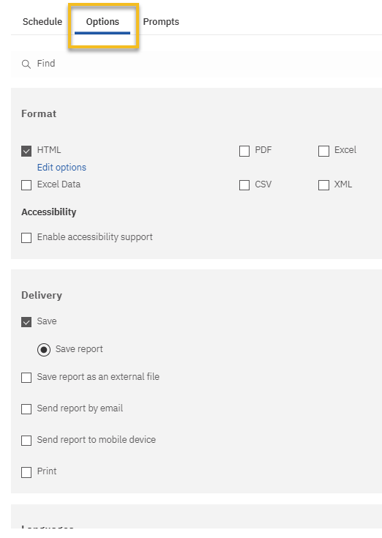
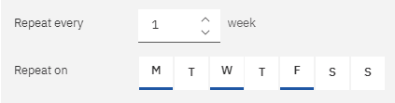
Delivery: Save report is required! A copy is saved on the Cognos server with the Report View.

Format: Select the format you would like the report to be saved in. You can select multiple output types.

Send Report: Choose this option if you want the report output to be delivered via email.
DO NOT USE

DO NOT USE
Options Tab settings:
- Options
- Formats: Select the format you would like the report to be saved in. You can select multiple output types.
- Delivery: Save report is required! A copy is saved on the Cognos server with the Report View.
- Save report as an external file: This requires a special set up. You must have made previous arrangements for this delivery type with the BICC
- Email delivery options: Email options are used to add additional users, update subject and body, and verify report output delivery. Use the information below to build your scheduled report email.
- Send report to mobile device: Do not use. This feature does not work.
- Print: Do not use. This feature does not work.
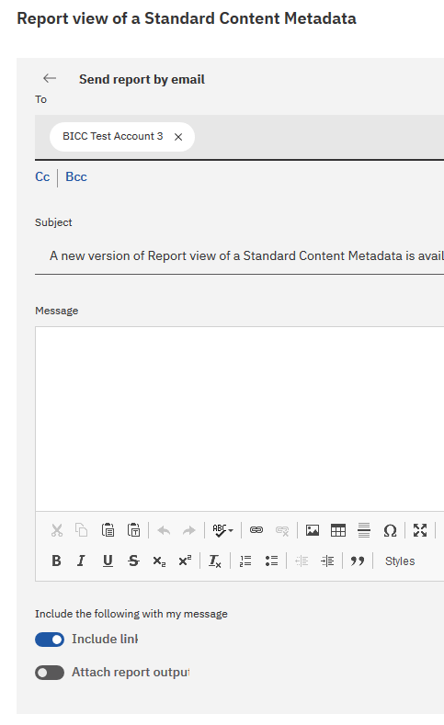
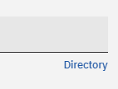
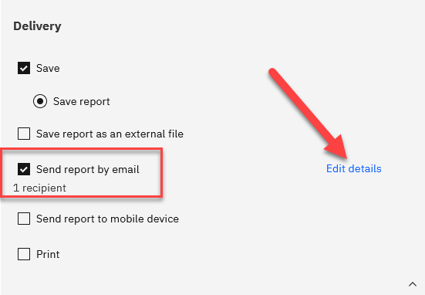
Adding additional recipients: Clicking to the right of your ID, begin typing another user’s FULL PURDUE EMAIL address. Once entered, you can either hit tab or enter to start typing the next user’s email address. You can also select the Cc: or Bcc: box to add the user email(s) instead. You can also use the Directory if the recipient(s) are within the University.
Send Report by email: Make sure this option is selected. *Notice: You are the one recipient.
Select Edit details to add other recipients (optional). This location also allows you to customize the email.

- Select the back arrow to save any changes
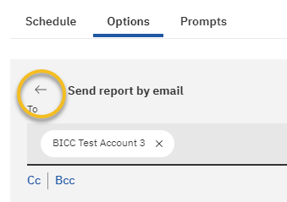
Subject line & email body: You can revise the subject line and enter additional information into the email body if desired.

Including a link: Use this option if the report contains sensitive data. Recipients must click on the link and log in to Cognos to review the output. Recipients must have a Cognos license to use the feature. This is the more secure option for report delivery.

Attach report output: Use this option if you want the output as an email attachment. All output types can be attached. This option is less secure. Consider any sensitive report and size output before using this feature. A Cognos license is not necessary to view the output.

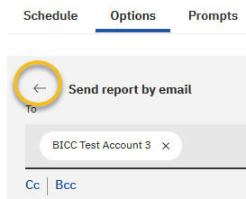
- Select the back arrow to save any changes

- Choose Prompts to set values.

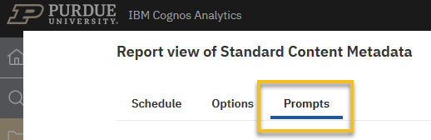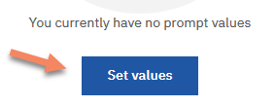

- Prompts: This is where you will maintain the prompt values if the report contains a prompt.
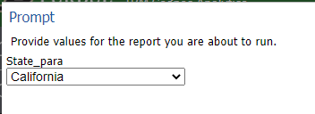

Example of other prompt pages:

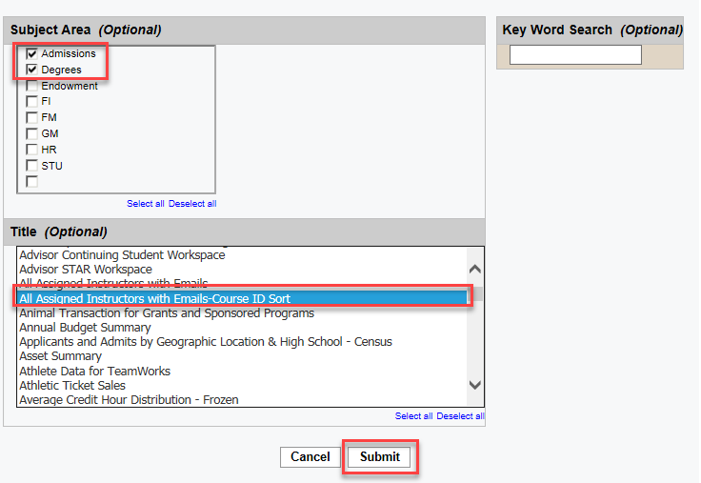
- The three prompts are optional for this report and therefore would not need a value choice. However, in this case, the values will be set. Choose the prompt values shown below, leave the Key Word Search prompt blank, and then click Submit. *The prompts are now saved on the schedule.

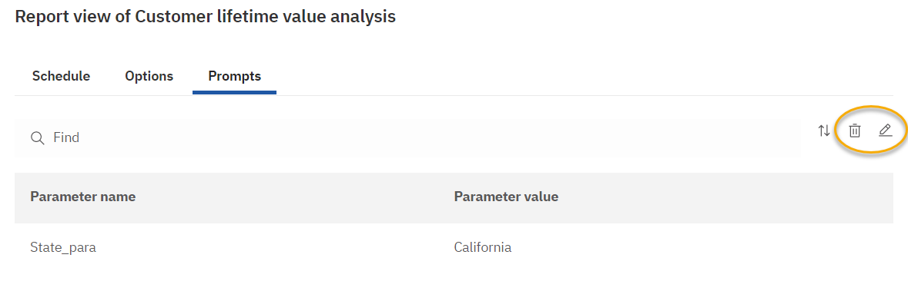
- The values are now in the Property pane in the Current values pane. You can delete or edit the values by clicking these icons.

- Click on the Save on the Properties pane to create the schedule.

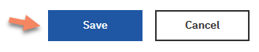

Edit Prompts in a Schedule

- Navigate to open My Scheduled Reports folder. Click the ellipsis to the right of the report title, choose Properties, then click the Schedule tab.

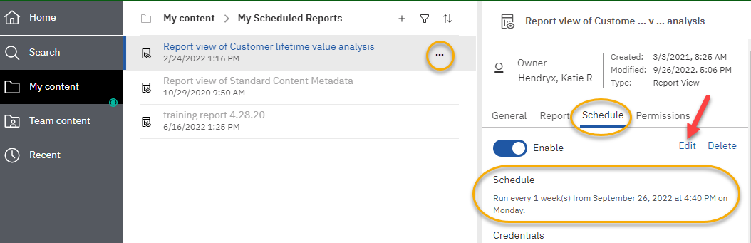
- Click on the arrow for the schedule just created.

- To edit the prompt values, click the Edit
- Go to the Prompts tab.
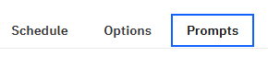
- The Current values pane will open. Choose Edit and update the prompts as desired, or you may also choose Delete to remove all prompt values.
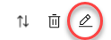

- Click Save on the Properties pane.

Disable or Delete a Schedule
- Click on the ellipsis of the Report View
- Choose Properties
- Click on the Schedules tab
- To disable the schedule, click on the white circle next to Enable.

Clicking on the white circle will enable (or disable) the schedule. Schedules are automatically enabled when the schedule is created
- To delete a schedule, click Delete. The schedule is deleted.

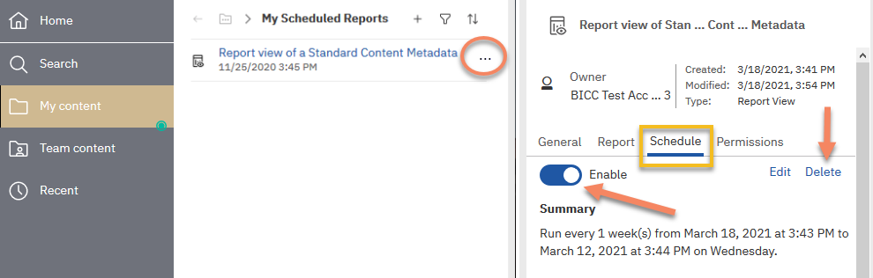

Set Report Outputs and Run Histories
By default, Cognos keeps a Run history of 5 occurrences so you can verify the report processed each time as expected. There is also a Report Output Version that keeps the data results from report runs.

- Navigate to the Customer Lifetime Value Analysis report. To do so, open My content > My Scheduled Reports.
- Click on the ellipsis to the right of the report name and choose Properties
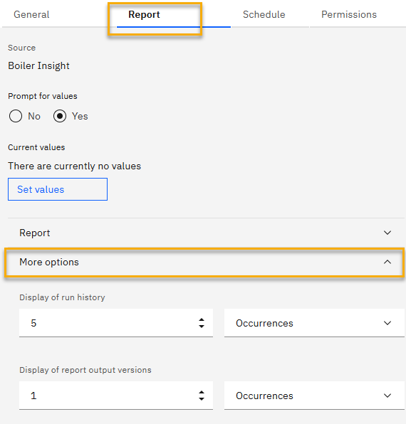
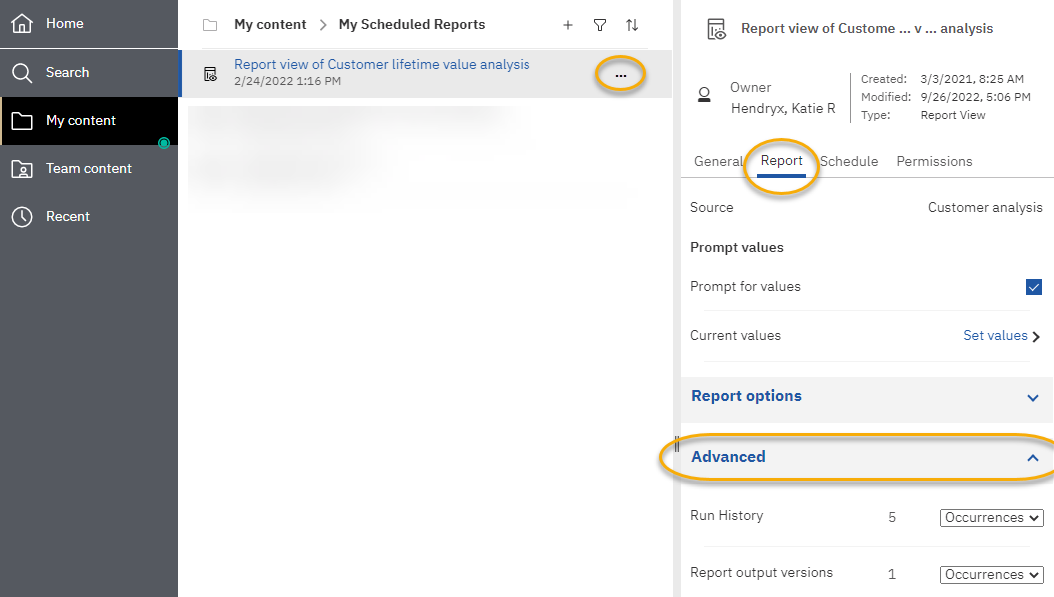
- Click on the Report tab and then click on the More options down arrow.

- Run history: displays processing details. This is a nice feature for testing run times when authoring reports. The run history defaults to the value of 5. You can change the Number of occurrences (double-click on the 5 and set it to the desired number of occurrences) or select the Duration based on your needs (click on the down arrow and set it to the desired duration, choose Day(s) or Month(s) on the drop-down list).
- Report output versions: the number of outputs you want to retain in the content store in Cognos. The run history defaults to the value of 1. When you run and save the report again, it removes the first occurrence and replaces it with the new one. You can change the Number of occurrences or select the Duration based on your needs, as you did for the run history.

Note: These values typically do not need to be changed. Consider the real need for multiple versions. Storing too many copies can affect Cognos’ performance for all users and/or cause user confusion.

View Run History
- Navigate to the Customer Lifetime Value Analysis report. Open My content > My Scheduled Reports.
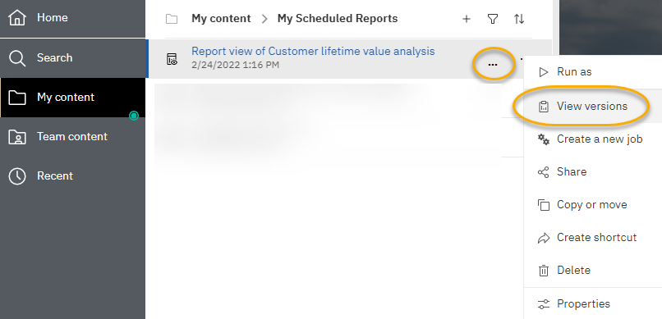
- Click on the ellipsis to the right of the report and choose View versions.

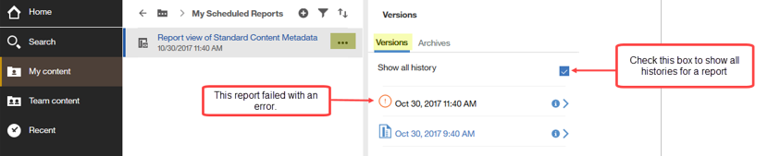
- The Versions panel will open. The last saved version of a successful execution of the report is listed. Check the Show all history box in order to view all the executions of the report that are available. You can change the Number of occurrences or Report output versions based on your needs within the schedule itself.

- Notice that in this example, the first report failed with an error message. To view a successful execution or an error message, click on the blue arrow to the right of the date and time.

WARNING: If you click on the name of the report to generate a new report interactively (not scheduled), Cognos will display the last saved version output!

Pictured below are the details concerning each execution of the report.
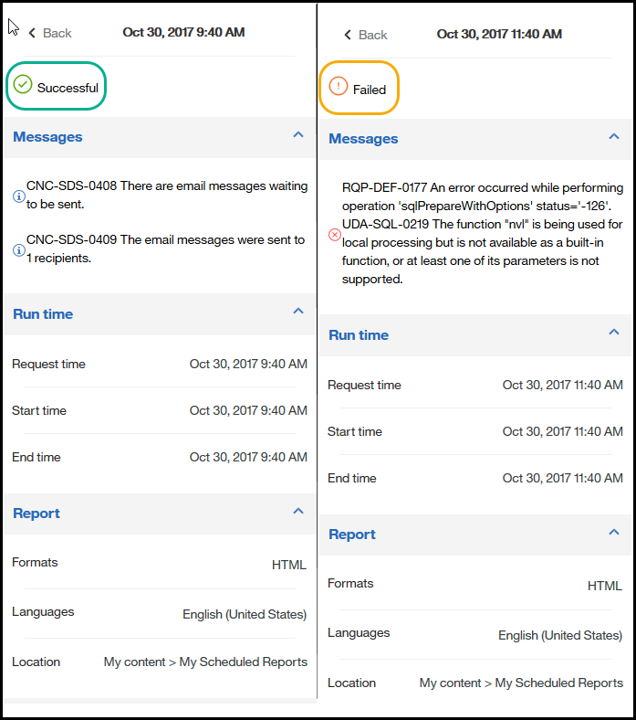

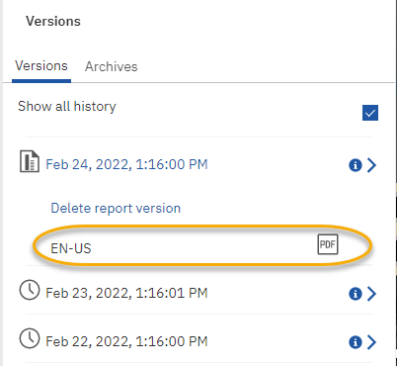
- Clicking on the output type will open the report in the associated format.

- If the report(s) are no longer needed, click on the Delete report versions next to the report output.

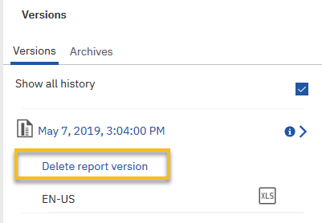

- Click OK in the warning pop-up window.

NOTE: To rerun the report for current data, you will need to click the ellipsis next to the report name and choose Run as. This will not execute the schedule.

Using Jobs to Schedule Multiple Entries
A job allows a user to set the same schedule for multiple reports, report views, and other jobs. The collection of reports (entries) is categorized into a job and scheduled together, sharing the same schedule settings. Therefore, when a scheduled job runs, all the entries in the job run. Users can specify running a job all at once or in sequence.
This QRC assumes users know how to create report views and schedule reports.
- Launch Cognos.
- Create report views of the reports you intend to use in the job or move reports to a specific folder if necessary.
- NOTE: Disable any schedule(s) currently on the report view(s) you intend to use in the job. If the schedule is not disabled, it will run along with the job schedule.
- Each report view within the job can be customized (Output format, Delivery, and Prompt selections).

Creating a Job
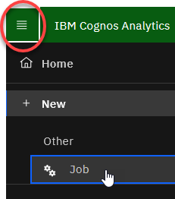
- To create a job, select the Open menu, the +New option, and then choose the Job choice.

- Click on the plus sign to add reports or report views to the job.

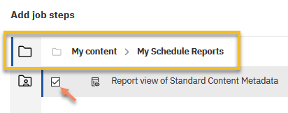
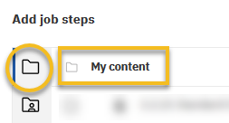
- Go to your My Content folder, and in the My Scheduled Reports folder, and check the box next to Report view of a Customer Lifetime Value Analysis

- Now click Add job steps
- It is recommended that the prompt values are set in the report view. Setting prompt values in the report view will allow for easier management.
- Hover over the report view and select the pencil to Edit options

- The Options Tab allows you to select the report output format as well as the delivery option.
- The Prompt Tab allows you to save the prompts on each report view.
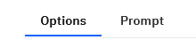
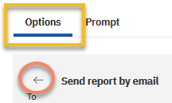
Emailing the Reports within a Job
- The same process is completed to create a scheduled report.
  - Select a format: HTML
  - In the Delivery section, select Send report by email
  - Click on Edit details to add recipient(s) to the scheduled Job.
  - Use the arrow under the Options tab to get back to the options menu.

- Now click on the Prompts tab.
  - Click on Set values to enter your prompts.
  - When finished, click Submit/Finish, and now your prompt values are saved.
  - Select Close to get back to the Steps page.

- In the Run Options section, under Run Order, select Run in sequence.
  - The Run in sequence selection means the entries are executed in the order they appear in the Steps list. Run in sequence means that when one report finishes running the next report will run and is BEST PRACTICE as this allows report executions to be staggered so the system resources are not taxed.
  - Make sure Continue on error is Enabled. If this is checked, the job will not stop if it runs into an error with a report.

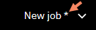

- If an asterisk is still visible on the Application bar, the Job has not been saved. Click Save

- Select the location where you want your Job housed. It is recommended you save the job and report view(s) in the same folder location.

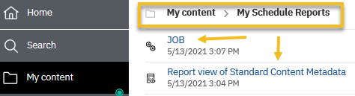
- Enter the name for this job and click Save in the My Schedule Reports folder.

Scheduling the Job
- Navigate to the folder that contains the job.
- Click on the ellipsis to the right of the job and then the Properties option.
- Select the Schedule tab and click on Create schedule.

- Another way to view your schedule options is to go into the Job properties
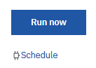
- Notice that under the Run Options area, Run Now is an available option as well as Schedule

  - Run now allows you to run all reports in the job easily.
  - Schedule is a feature to run the job(s) at recurring dates and times based on your business needs. The output can be saved to the Cognos servers and/or emailed to users’ Purdue email accounts. Users can disable and re-enable the schedule without removing the report(s) from the scheduled objects.

- Click Schedule and Create schedule
- Select the appropriate Frequency and Start/End time for the schedule.
- Then Save. The job set-up is now complete.
Editing the Job or Schedule
- Navigate to the folder that contains the job.
- Click on the ellipsis to the right of the job and select Edit the job option.

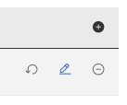
Reset Options to Default: Removes the output format and delivery of the Report view
Edit Options: Allows you to customize the output format, the Job delivery, and make edits to the prompt selections
Add Reports: Click the plus sign to add additional reports to this job
Remove Job Step: Deletes the reports within the Job

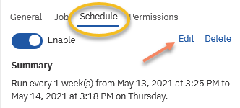
- To make changes to the schedule, go to the Schedule tab.
- Click Edit to get into the Job Schedule.

- Click Save when finished editing the job properties or schedule.

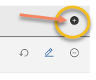
To add a report view to an existing Job
- Navigate to the folder that contains the job.
- Click on the ellipsis to the right of the job and then the Properties option.
- Select the Job tab and click on the word Advanced.
- Click on Set to open the Job.
- Click on the plus sign to Add Job Steps
- NOTE: Repeat steps 3-15

Subscriptions
Subscriptions are reports you set up to run on a schedule. This could be useful for reports that you run for auditing regularly.

Setting up a Subscription

- Navigate to the Sales Summary report following the breadcrumb menu below. Click on the ellipsis on the right side of the report name, Customer Lifetime Value Analysis, and choose Run as.

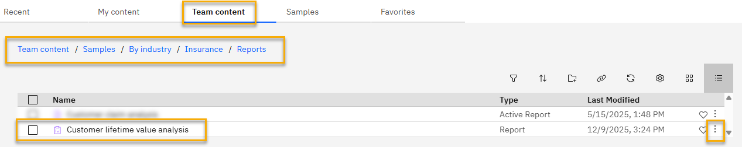

- The Run As pane will open. Click Run.

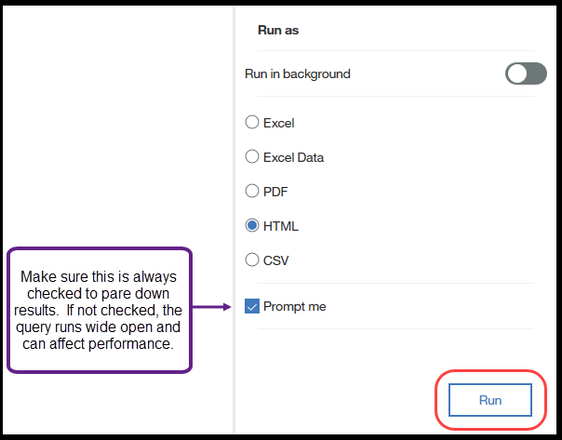
This report does not have any prompts, but if it did, the prompt pane would open here, allowing you to filter the report.

- Once the report executes and displays the results, click the More ellipsis and choose Subscribe.

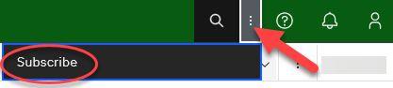
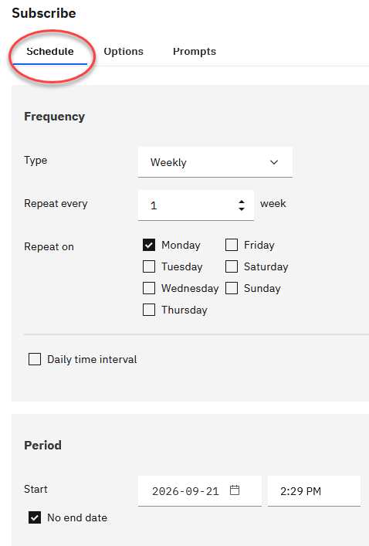
The Schedule tab will open.
- Select your frequency and how often you would like the subscription to run.
- Select the subscription start date. If you leave No end date selected, the subscription will continue indefinitely. If you know when the subscription should end, choose an end date.
The Options panel will open. This is where you set/review the report subscription options.
- You can choose multiple formats as you did for a schedule.
If the report contained prompt values that you chose when you executed the report, they are retained and can be updated here. You can edit and update different prompt values by selecting the prompt tab.
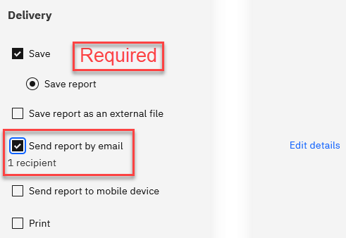
- Click on the Delivery arrow.

- Click on Save, then Create to create the subscription.

My Schedules and Subscriptions
My Schedules and Subscriptions displays user schedules and subscriptions and can be used to research failed report schedules, delete schedules/subscriptions, and modify schedule/subscription rules.
- On the Application bar, select the me icon. 
- Click on My schedules and subscriptions.
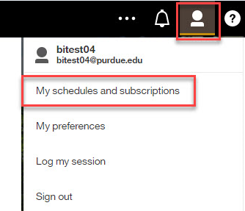

- Your schedules and subscriptions will be displayed.
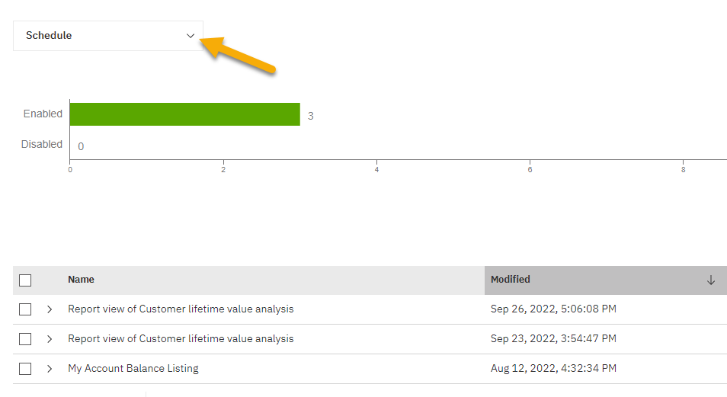

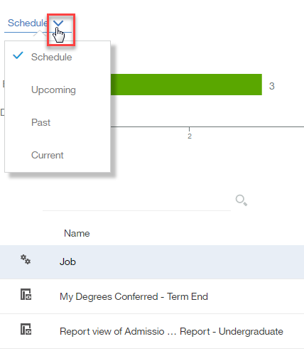
- The default view of the My schedules and subscriptions space is set to Schedule, but you can choose from the switcher which view you would like to see.

- To view the properties, modify the schedule/subscription, and other options, click on the ellipsis to the right of the schedule/subscription and choose the appropriate choice.
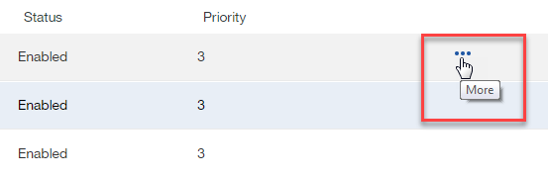

- The options are dependent on if you are looking at a schedule or a subscription.
Schedule | Subscription
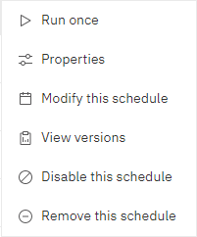 | 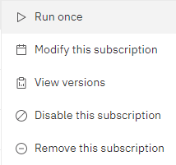

- The Schedule choices allow you to modify your schedule along with many other options which were described earlier in this manual, starting on page 11.
- The Subscription choices allow you to modify your subscription, view your subscription’s versions, disable the subscription, and remove the subscription.
- To cancel a scheduled report or a report running in the background, use the Current view to Cancel the run. Using the Cancel feature is helpful in keeping the Cognos server performing at optimal level when a report is not returning as quickly as expected.
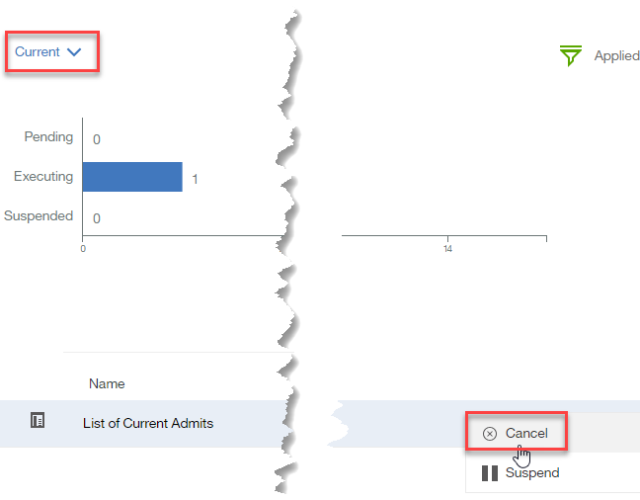

Departmental Scheduled Reports
How do I know if I have write access to departmental folders?

Departmental scheduled output can be based out of departmental folders if the user has write access to the folder containing the report. This works well if users within the department need to share report output. Please work with your Cognos Departmental Administrator on the preferred option for your area.
Note: Users MUST have write access to the departmental folder where the report is stored to set up a schedule within the departmental folders.

Do I Have Write Access to My Departmental Folder?

- Find a report currently saved in your Cognos departmental folder.
- Click on the ellipsis to the right of the report name.
- Click on Properties.
- Your permission will be under the word Permission. You will need either Write or Full permission to save to your departmental folder.

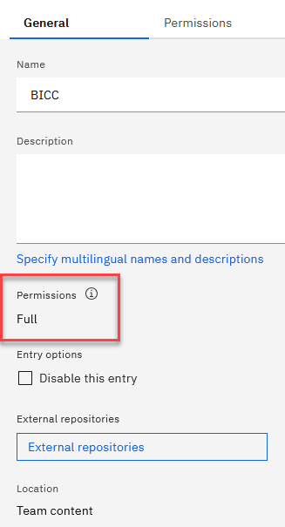

Please work with your Cognos departmental administrator for questions on folder access and/or scheduling shared departmental output.

Renewing Cognos Credentials after Network Password Change
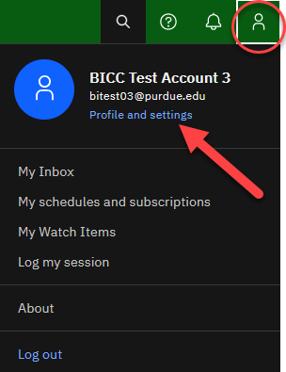

Renewing your credentials in Cognos after changing your network password is required to avoid disruption of scheduled reports running on a daily, weekly, or monthly basis.
- Log in to Cognos and click on the icon;
Click on the Profile and settings link.

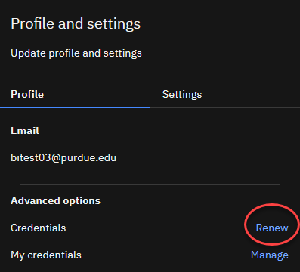
- On the Profile tab, click on Renew.

- A message box will appear confirming the credentials have been renewed.

Cognos Scheduler Policies and Procedures
Below are the policies and procedures for using the schedule component in Cognos. The policies are used to protect the shared environment, which affects all report consumers. Abiding by best practices and adhering to policy will preserve the integrity and performance of the Cognos reporting environment for all.

User Process / Schedule | Explanation / Risks | BICC Policy / Actions
Student data reports are NOT to be scheduled or run between  12:00 AM and 5:00 AM.  HR and FI data are NOT to be scheduled or run  Monday-Friday 6:00 AM to 7:30 AM  Saturday 9:00 AM to 9:30 AM | This is to allow the overnight processes within ODS and SAP to be completed. Scheduled or manually running reports during those hours will result in no data, incomplete data, or incorrect data, which slows down the delivery of data for all users | The BICC will review the schedule quarterly for reports scheduled during data processing times. Users will be notified to change schedule times.
Scheduled reports should NOT be scheduled between 4:00 PM and 12:00 AM on Saturday nights. | These times are Purdue IT maintenance window times and should be avoided, as systems can be down during this time. | The BICC will review the schedule quarterly for reports scheduled during data processing times. Users will be notified to change schedule times.
Keep saved report outputs to a minimum for business needs. | Move the saved output to another secured location or delete it. | The maximum number of output copies allowed is dependent on the number of copies and/or file size. Deletions will be at the discretion of the technical team and user.
Disable inactive scheduled reports from the scheduler when not being actively used. | Change status to Disabled when the schedule is not needed for a short length of time. Like term-to-term reporting. | The BICC will review the schedules bi-annually and remove expired or failed reports.
Delete reports from the scheduler when no longer needed or past their expiration date. | This aids in keeping the maintenance manageable within the Cognos systems. | The BICC will review the schedule quarterly and remove expired or failed reports.
Renew credentials each time your Purdue account password is changed. | Scheduled reports will not run until the credentials are updated. | BICC will review credential issues and send users a warning email.
Departmental report Schedules should be scheduled from departmental folders. | My Content should not contain departmental scheduled report data. My Content is for personal report consumption. The risk is employee changes and losing report data if the report was scheduled from My Content. | Objects from My Content will be deleted 30 days after an employee separates from the university.
*Disabled or Expired schedules over 1 year old are subject to removal without notification.

Cognos Scheduler Best Practices Guide
The list below contains best practices for using the schedule feature. Abiding by these guidelines will assist in keeping the Cognos systems running smoothly for everyone. Please refer to them when considering adding a report to the scheduler.

- Make a Copy of the Original Report - This will avoid saved scheduled copies being unknowingly used by others. Schedule departmental reports from the departmental folders. Copies can be saved within your My content, but if the report output is to be shared with others, place the copy in the departmental folder. Use the Create report viewfeature found with the original report to make the copy. Report View ensures your new scheduled copy will receive any updates made to the original report. Shortcuts are problematic, as links are broken if the original report is moved to another folder in Cognos. Using Report View ensures you will not lose your link to the original report.

- Use My schedules and subscriptions – This feature is found under the me  icon on the Application bar. It displays user schedules and subscriptions and can be used to research failed report schedules, delete schedules, and to modify the schedule rules.

- Remove Inactive Schedules and Subscriptions - Review your Schedules and Subscriptions and delete those no longer needed. This helps prevent unnecessary reports from running against the Cognos system.

- Maintain a Record of Current Schedules – Create a spreadsheet of scheduled reports. Include when the report is scheduled to run, any date/term prompts and when they need to be changed, and everyone who receives a copy of the scheduled output. This will also help you maintain proper report output and aid supervisors in the event of employee departure or time away.

- Cognos Email Notifications – Users need to be aware when Cognos is unavailable and if it will affect your scheduled report(s). Watch for Cognos, ODS, EDW, or Boiler Insight (HR and FI) email notifications from the BICC containing information on system downtime.

Please take time to review email messages and be aware of any scheduler disruptions. Users may need to run the reports manually if Cognos was unavailable during scheduled run times.

Troubleshooting
Users may contact BICC at bicc@purdue.edu with questions specific to this manual or for any Cognos questions or issues.

Feedback on this Document

Questions and feedback specifically about this document are welcome. Please email your comments to bicc@purdue.edu.

